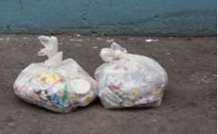

**THANK YOU**

STUDENTS, RANGERS and MONITORS

FOR DOING AN amazing job!

Keep up the great work!

Keep**KEEP UP**

**THE GREAT WORK!**

CAFETERIA CULTURE

**x bags**

**x pounds**

Put a photo of your “before” cafeteria

garbage here!

Put another photo of your Cafeteria Rangers here!

We ***decreased*** the amount of **garbage** by:

* XX pounds of food scraps
* XX pounds of compostable plates
* XX pounds of *recyclable*s
* XX pounds of *recyclable* paper and board

Put a photo of your “after”

cafeteria garbage here!

Put a photo of your “before” cafeteria garbage here!

Put another photo of your Cafeteria Rangers here!

Put a photo of your Cafeteria Rangers here!

After 

**xx bags**

**of garbage per day**

**xx pounds**

AMAZING FIRST DAY!

[www.cafeteriaculture.org](http://www.cafeteriaculture.org)

*(Date here)*  **EXTRA! ZERO WASTE NEWS- *(school name)***  *(City here)*

Jan.. 14, 2016 EXTRA! ZERO WASTE NEWS - NEST+M New YORK., NY

Diverting a total of xx **pounds** from going to a landfill and incinerator!

xxxx, 2016 - **LAUNCH DAY**

We went from xx bags to just x bags of garbage!

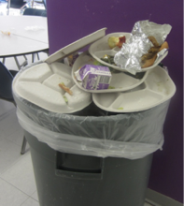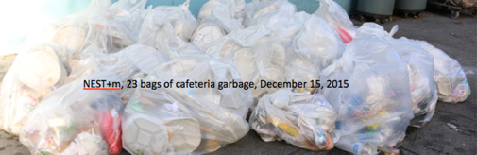

Before